**Human computer interaction and communication**

**EXERCISE 02 Solution – Website analysis**

# Name: Ibrahimi Nematullah

PURPOSE

The purpose of this exercise is to familiarize you with the first law of usability: Don’t make me think! In today’s exercise, you will work with your classmates to analyze websites and discuss what websites make you think and which ones do not.

ACTIVITIES

Perform each of the following activities. If you have questions, issues, or doubts, please ask for help and do not just guess.

1. Discuss the following questions with the rest of your classmates. The questions should be related to the scope of your project. Insert your answers into the space provided:
   1. What websites or application features make you think too much? (give 10 examples of poor usability (screenshots & description))

Answer: I have searched about the website of Lublin University, and I have found the following poor usability.

**-: Not understandable.**  


**-: Not working smoothly.**

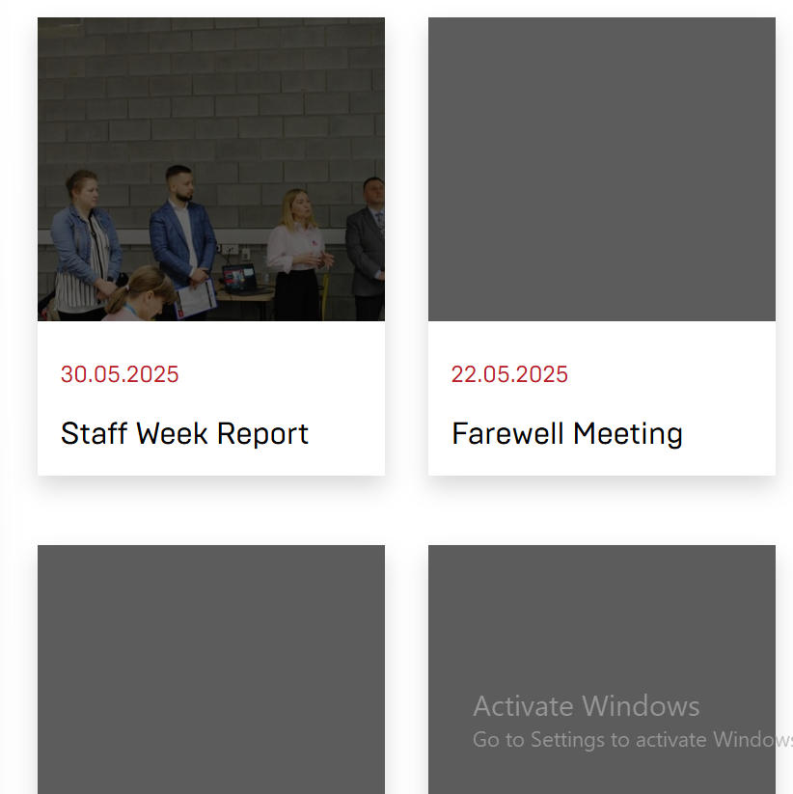

**-: Not sensitive color design.**  


**-: Too many choices:**  


**-: Boring for users.**

**-: Not having good elements like light mod button.**  
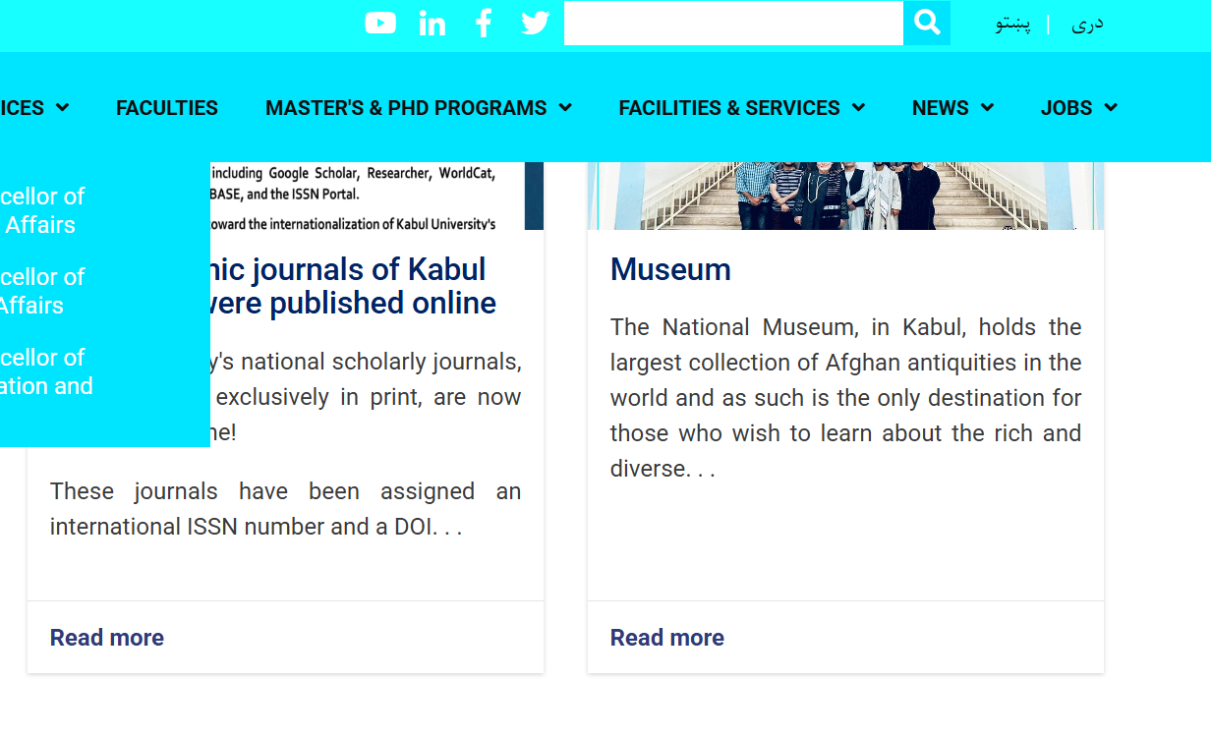

-: **Not having register button on the first page makes it hard to navigate and find it.**  


**-: Having ads and more options on the first and search page.**  
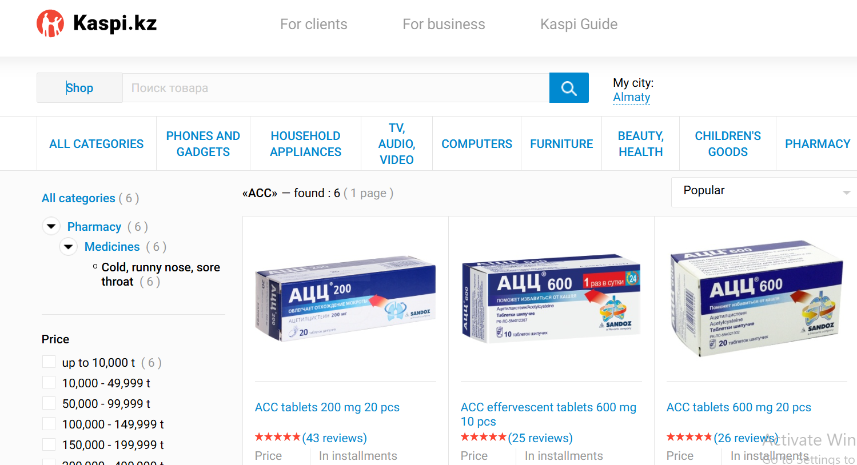

* 1. What are your suggestions to not make the user must think about those features? (give 10 examples of how to solve poor usability problems).

-: Instead of shapes, simply they could use texts like Satbayev website

-: They should use lazy loading with proper image fallbacks to keep the page smooth and responsive.

-: Erasmus app is a positive point for the university I think it would be better if they chose colors like light green instead of dark red.

-: Inserting the contact number, email, and link of social pages in top of the page next to the search box is reducing what we wanted to search for and, they used not sensitive colors.  
They could use those contacts at the bottom of the page and used smooth colors not to annoy our eyes.

-: Instead, they could publish different materials to increase their webpage validity and attract more students.

-: As bright colors they have used, we see they annoy users’ eyes and there is not dark mod button.  
I think they have used dark-light mod button to predict annoying users’ eyes.

-: Putting register button on the first page makes registering easier and attracts new users.

-: Ads on the search page attract users and users may even forget what they wanted to search. They could make the page simpler like google search page.

* 1. What makes a website or application usable, user-friendly, an effective user experience?  
     Answer: A website or application or application is usable and user-friendly when it is simple and understandable like google search page, easy to navigate, responsive, and works smoothly without confusion or frustration.
  2. What is the first law of usability? What does it mean?

Answer: In my opinion the first law of usability is “Don’t make me think.” It means that the website should be so clear without any additional ads and intuitive that users can understand how to use it and achieve their goals. The best example I can provide is Google website.

1. Save your finished document and upload it to the LMS. Make sure you have:
   1. Added your name to the space provided at the top of this document
   2. Renamed the document to include your Student ID.